
Applied Science Private University
Faculty of Information Technology

Information Systems Analysis and Design
1301386

Course Project 20251

Project Title:

Spotify



Prepared by:

Joud Zayed 202311160
Malak Al-Qaralleh 202311545

Jan 2025
Copyright © 2025-2026 Applied Science Private University. All rights are reserved
Contents
Abstract: iv
Chapter 1: Introduction 3
1.1 Description of the current situation and opportunity 3
1.2 Problem statement (limitation of current systems) 3
1.3 Problem solution 4
1.4 Project objectives 4
Chapter 2: Requirements and Analysis 5
2.1 Software Process Model 5
2.2 List of Functional Requirements and Non-Functional Requirements 5
2.3 Use Case Diagram with Use Cases descriptions 7
2.4 Data Flow Diagram ………………………………………………………………...7
2.5 Activity Diagram…………………………………………………………………….
2.6 System Sequence Diagram……………………………………………………………
Chapter 3: Design 19
3.1 Conceptual Class Diagram 19
Appendix: 20

User- Interface Design
References

Abstract

This project proposes enhancements to the Spotify application aimed at improving listening continuity, social interaction, and user control. The proposed system introduces auto-mixing between songs for smoother transitions, an internal chat feature for sharing music, increased free skips, a song-part gifting feature, a mood lock option based on the user’s own playlists, and easier navigation to the previously played song. The scope of the system focuses on enhancing user experience while maintaining Spotify’s core streaming functionality.

Chapter 1: Introduction

Description of the current situation and opportunity
Spotify is one of the most popular music streaming platforms in the world, offering millions of songs and a variety of personalization features. The platform collects massive amounts of user data, including listening history, playlists, skips, likes, and other interactions. This data allows Spotify to provide highly personalized recommendations. Features like Discover Weekly and Fresh Finds help users discover new music, even from lesser-known artists, by analyzing user behavior and song characteristics (Kurt Jacobson, 2016).
Music also reflects people’s emotions and moods. Recent studies analyzing Spotify data from over 50 countries show that global listening habits change over time and can be influenced by external factors such as the weather or major events like the COVID-19 pandemic. Researchers have even developed models that can predict what type of music people are likely to listen to in the future based on past behavior and these contextual factors (Terroso-Saenz, 2023). This demonstrates that while Spotify’s recommendation system is already advanced, there is still room to further enhance user engagement by considering global trends and emotional context.
Despite these achievements, user expectations continue to grow. Many users want smoother transitions between songs, more control over playback, and better social interaction within the app. This presents an opportunity to enhance Spotify by adding features such as auto-mixing, chat for sharing music, mood-based playlist options, and simpler navigation to previously played songs. By addressing these needs, Spotify can provide an even more immersive, social, and user-controlled listening experience without changing its core purpose.

Problem statement (limitation of current systems)
Even though Spotify is extremely popular, there are still some aspects that could be improved. Sometimes, the transition between songs feels sudden and can interrupt the listening experience. Free users have limited shuffle and skip options, which makes it harder to navigate playlists freely. The app also doesn’t have a built-in way to chat or share music directly with friends, which limits the social side of listening.
Users also struggle with controlling mood-based playlists from their own music collections, and going back to a song they just played isn’t always easy. These issues may seem small individually, but together they can reduce the enjoyment of listening and make the app feel less interactive and personal. Clearly, there’s room to improve playback control and social features to make the experience smoother and more engaging.

Problem solution
4

Project objectives

The objectives of this project are to:
- Improve song transitions and listening flow
- Enhance social interaction within Spotify
- Increase user control over mood and playback
- Improve the experience for free-tier users

Chapter 2: Requirements and Analysis

Software Process Model

We chose the Agile model because our project improves the existing system and requires continuous user feedback. Since our features focus on user experience, we expect changes during development. Agile allows iterative development, frequent testing, and flexible modification, which reduces risk and results in a more usable system.

List of Functional Requirements and Non-Functional Requirements

Functional Requirements:

1. The system shall allow Auto-Mix and Playback Control
1.1 The system shall automatically mix songs to provide smooth and seamless transitions.
1.2 The system shall minimize time changing the song.
1.3 The system shall minimize volume while changing songs.
1.4 The system shall mix the mood between songs.

2. The system shall provide social interaction features.
2.1 The system shall provide an internal chat feature that allows users to communicate
2.1.1 Users shall be able to communicate with friends on Spotify.
2.2 The user shall be able to send music suggestions through internal chat.
2.3 2 The user shall be able to send text messages.
2.4 2 The user shall be able to send pictures.
2. 2 The user shall be able to send videos.

3. The system shall allow the user to skip the currently playing song.
3.1 The system shall not restrict the number of skips available to the user.

4. The system shall allow users to back to the previous song.
4.1 The system shall provide a button to return to the previously played song.

5. The system shall allow users to gift a specific part of a song to another user.
5.1 The system shall allow the user to select a start and end time within a song.
5.2 The system shall allow the selected song segment to be sent to another user as a gift.
5.3 The system shall notify the recipient that a song segment has been gifted.
5.4 The system shall play the gifted song segment when the recipient taps the notification.

6.The system shall provide a mood lock feature for playlist.
6.1 The system shall allow users to select a mood only form their own playlists.
6.2 The system shall not allow users to select moods from other user’s playlists.
6.3 The system shall filter or shuffle songs based on the selected mood.

Non-functional Requirements:
1.Performance
1.1 The system shall make song transitions smooth, with no noticeable delay.
1.2 Chat messages and music gift notifications shall reach the recipient quickly.

2. Usability
2.1 The mood lock and playlist features shall be easy to find and use on both mobile and desktop.

Use Case Diagram with Use Cases descriptions

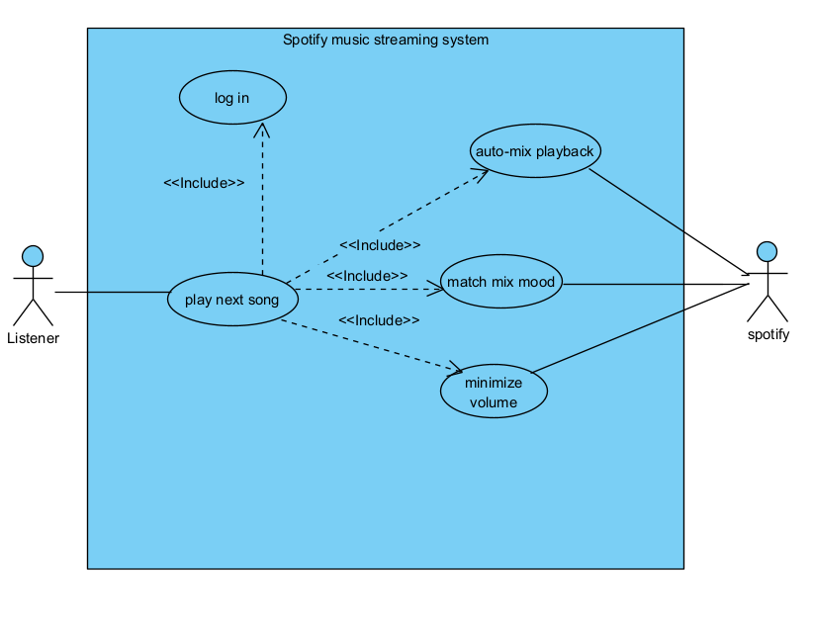
Figure 1: Auto-mix playback

ID | 1
Name | Auto-Mix Playback
Description | This use case allows the system to automatically mix songs to ensure smooth and seamless playback transitions while maintaining mood consistency.
Primary Actor | User (Listener)
Secondary  Actor | System (Spotify)
Pre-conditions | - The user is logged into the system.  - The user is playing on a playlist or album.  - Auto-Mix features are enabled.
Post-conditions | - The next song is playing smoothly.  - Playback continues without noticeable gaps or abrupt changes.
Normal Flow  (Happy path) | - The user starts playing a playlist.  - The system detects that Auto-Mix is enabled.  - The system analyzes the currently playing song.  - Before the song ends, the system selects the next song.  - The system automatically mixes the two songs.  - The system minimizes the transition time between songs.  - The system smoothly lowers and raises the volume during the transition.  - The system matches the mood between the current and next song.  - The next song starts playing seamlessly without interruption.
Alternative Flow | If Auto-Mix is disabled, the system plays the next song normally without mixing.
Include | - Successful log in
Extend | - Spotify premium
Exceptions

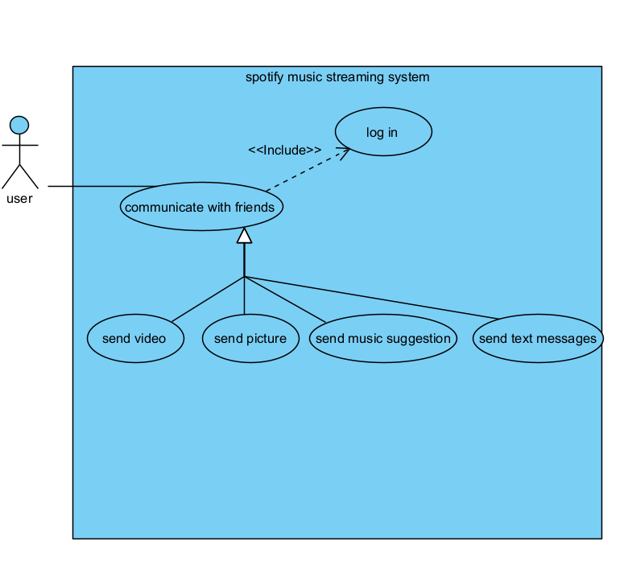
Figure 2: Internal chat
ID | 2
Name | Internal chat
Description | This use case allows users to communicate with their friends on Spotify using an internal chat system that supports text messages, music suggestions, images, and videos.
Primary Actor | User
Secondary  Actor | Friend
Pre-conditions | - The user is logged into the system.  - The user has at least one friend on Spotify.  - Internet connection is available.
Post-conditions | - The message or music suggestion is successfully delivered.  - The chat history is stored for future access.
Normal Flow  (Happy path) | - The user opens the Spotify application.  - The user selects a friend from the friends list.  - The system opens the internal chat interface.  - The user chooses the type of message to send.  - The user sends a text message, image, or video or selects a song to recommend.  - The system delivers the message to the selected friend.  - The friend receives the message in real time.  - The chat conversation is updated for both users.
Alternative Flow | In step 5: if media upload fails the system shall notify the user of the failure and the user may retry sending the media.
Include | - Successful log in  - Adding a friend
Extend
Exceptions | If friend had blocked the user message shall not arrive

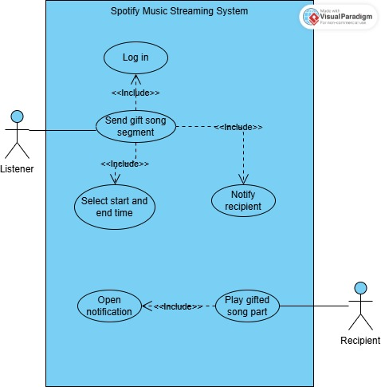

Figure 3: Gift song segment

ID | 3
Name | Gift Song Segment
Description | The listener selects a part of a song an send it as a gift to another user. The system notifies the recipient, who can then listen to the song segment.
Primary Actor | Listener
Secondary Actor | Recipient
Pre-conditions | - The listener is logged into the system.  - The recipient has a valid account  - Internet connection is available.  - The listener has selected a song
Post-conditions | - The system applies the selected mood to the playlist.  - Songs are filtered/ shuffles based on the mood.
Normal Flow | 1. The listener logs into the system.  2. The listener chooses the option to send a gift song segment.  3. The listener selects the start and end time of the song.  4. The system sends the selected song segment as a gift.  5. The system notifies the recipient.  6. The recipient opens the notification.  7. The system plays the gifted song segment.
Alternative Flow | In step 1, if the listener is not logged in first, the system asks the listener to log in first.  In step 6, If the recipient does not open the notification, the song segment will not play.
Include | - Log in into account
Extend | - Play song segment
Exceptions | In step 3, if the start and end time are revered, the system show an error message asks for a valid times.

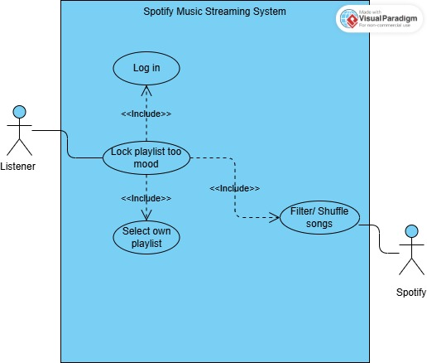

Figure 4 Lock playlist to mood

ID | 4
Name | Lock playlist to mood
Description | The listener selects one of their playlists and locks it to a mood. The system filters or shuffles the songs based on the selected mood, and the listener can then play the mood locked playlist.
Primary Actor | Listener
Secondary Actor | Spotify
Pre-conditions | - The listener is logged into the system.  - The listener has at least one playlist.  - Internet connection is available.
Post-conditions | - The listener is logged into the system.  - The recipient has a valid account  - Internet connection is available.  - The listener has selected a song
Normal Flow | 1. The listener logs into the system.  2. The listener chooses the option to lock a playlist to a mood.  3. The listener selects one of their playlists.  4. The listener selects a mood.  5. The system filters or shuffles the songs based on the selected mood.  6. The listener plays the mood locked playlist.
Alternative Flow | In step 1, if the listener is not logged in first, the system asks the listener to log in first.  In step 3, if the listener wants a different playlist, the system allows the listener to select another playlist.
Include | - Login into account  - Select playlist
Extend | -
Exceptions | In step 3, if the listener selects another user’s playlist, the system shows an error message says “You can only select your own playlists”.  In step 3, if the playlist is empty, the system shows an error message says “This playlist has no songs”.  In step 4, if no songs match the selected mood, the system shows an error message says “No songs match this mood”.

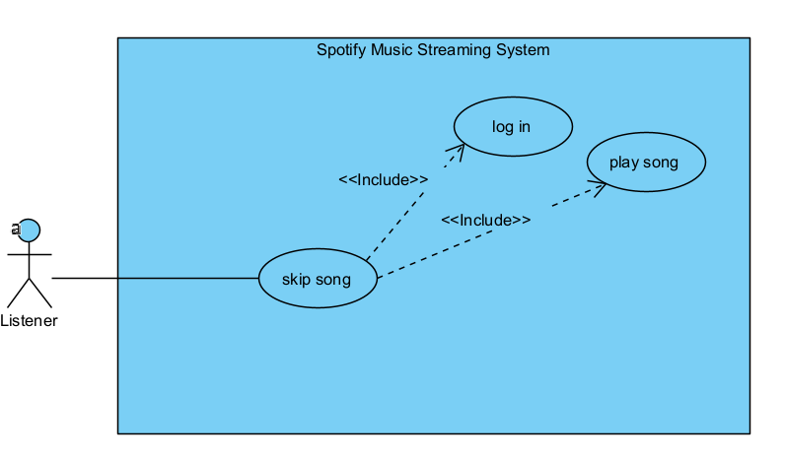
Figure 5: skip songs

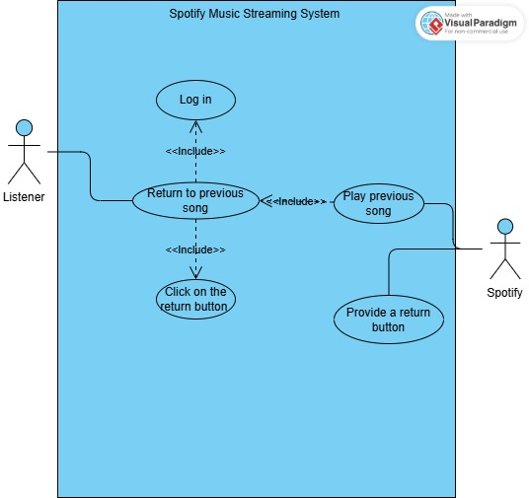
Figure 6: Back to previous song

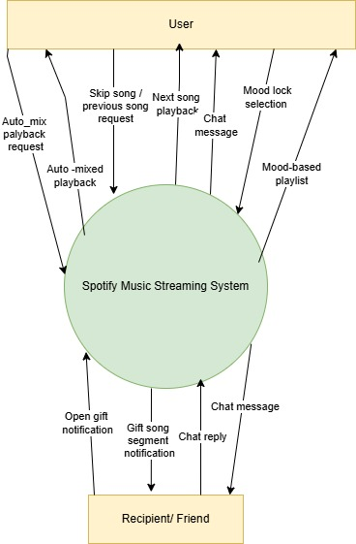
Data Flow diagram

Figure 7: Context Diagram (Level 0)

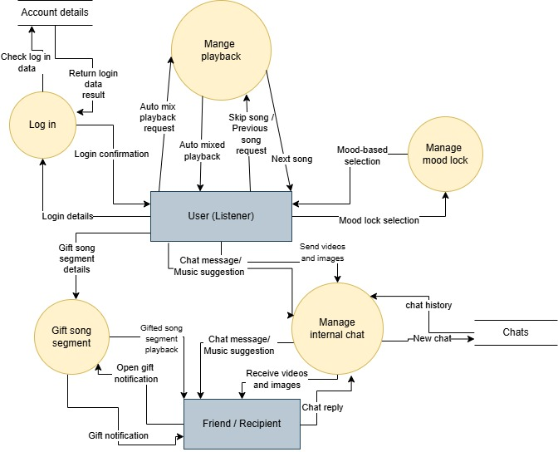

Figure 8: Data Flow Diagram (Level 1)

Activity Diagram
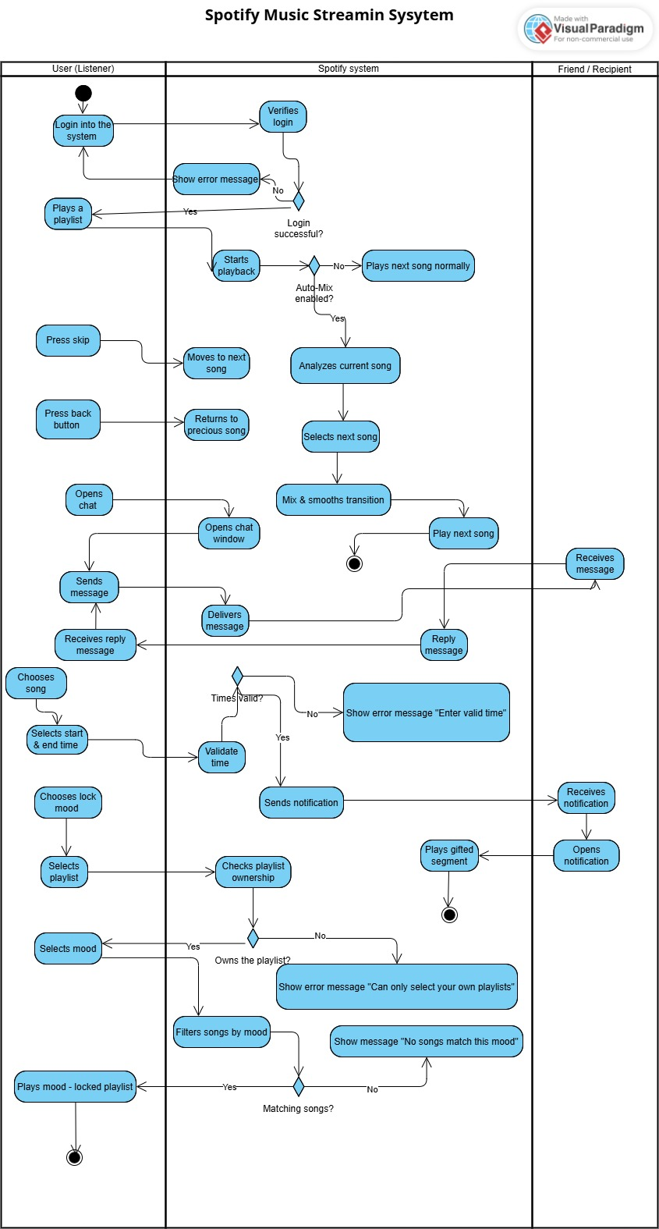
Figure 9: Swimlane Diagram

System Sequence Diagram

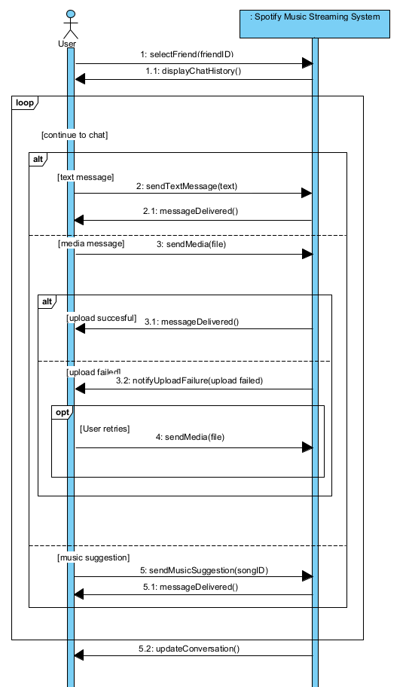

Figure 10: System Sequence Diagram

Chapter 3: Design

Conceptual Class Diagram

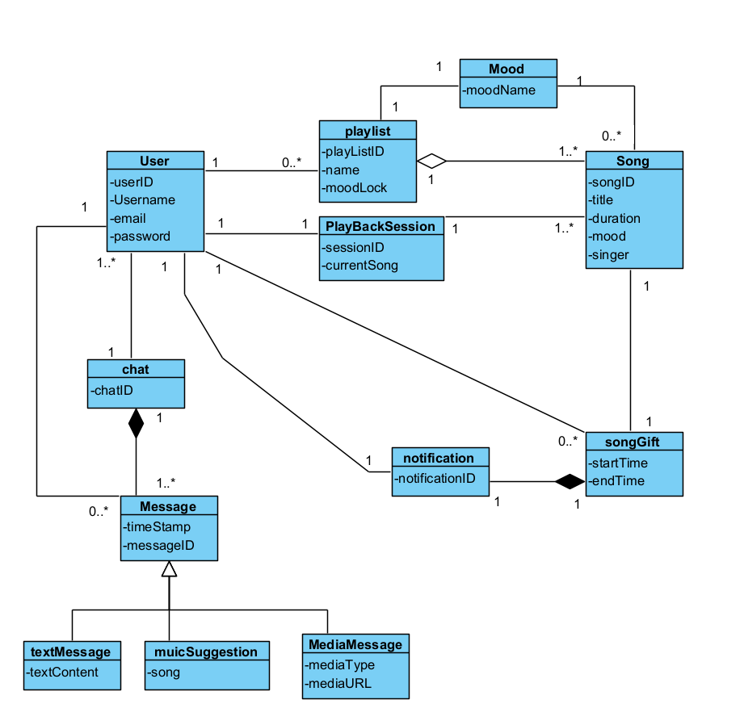

Figure 11: Conceptual Class Diagram

Appendix:
User-interface Design

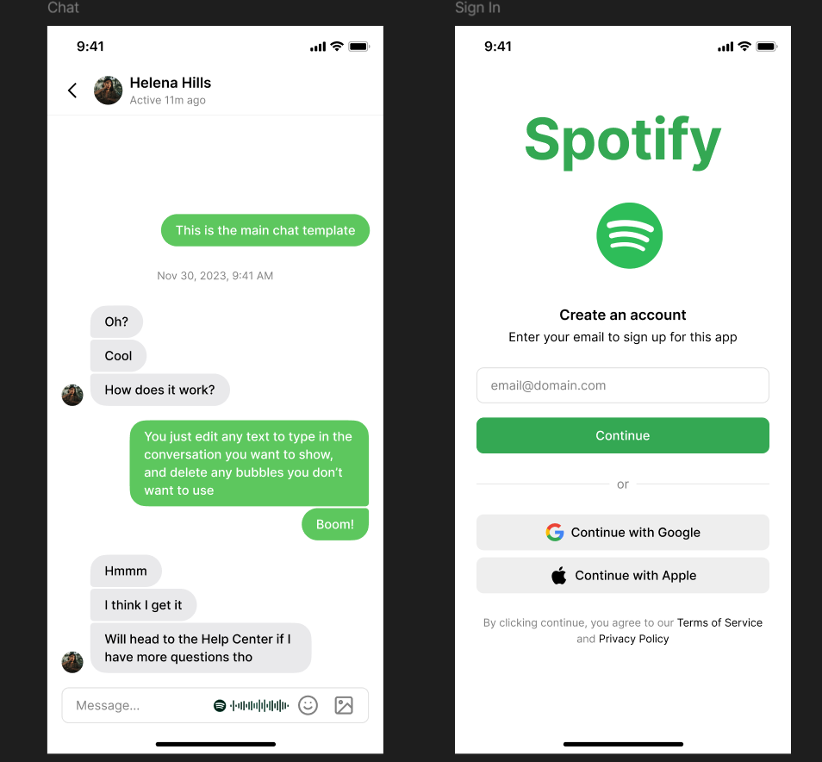

References
Kurt Jacobson, V. M. (2016). Music Personalization at Spotify.
Terroso-Saenz, F. (2023). Evolution of global music trends: An exploratory and predictive approach based on Spotify data.

